CENWP-OD-D 18 Aug, 2011

MEMORANDUM FOR THE RECORD

SUBJECT: Adult Steelhead mortality in Main Unit #17 Scroll Case.

On 6 July 2011, fisheries personnel entered the scroll case and observed two adult Sockeye mortalities. The suspected cause was due to backflow from the ice/trash sluiceway until the sluiceway level could be lowered to allow installation of an orifice closure plate. An unusually large number of fish were found in this scroll case dewatering. A memo was provided to FPOM members. If the sluiceway is taken out of service and lowered prior to dewatering the unit, a much longer outage( >5 hours vs ½ hour) would be required, which is not desirable during fish passage season since sluiceway is an important route of juvenile passage.

On 17 August 2011, gatewell 17-1 water level was lowered to install an orifice plate. In the following order, a bulkhead was installed, rollergate removed and sluiceway lowered. Orifice backflow during this time (<1/2hour) resulted in the following mortalities of 1 steelhead, 1 sucker and 3 shad. They were observed atop the bulkhead. Fish in this area are not normally observed and access is difficult.

- Time and date: 1130 hrs, 17 August 2011.
- Nature of activity: Main Turbine Unit 17 gatewell dewatered for VBS removal and orifice plate installation.
- Agency responsible: U.S. Army Corps of Engineers.
- No visible marks from distant observation.
- Future actions: Investigate procedure steps to determine how to keep fish in water and/or safely access for removal.
- Relevant photo: top of intake bulkhead with mortalities
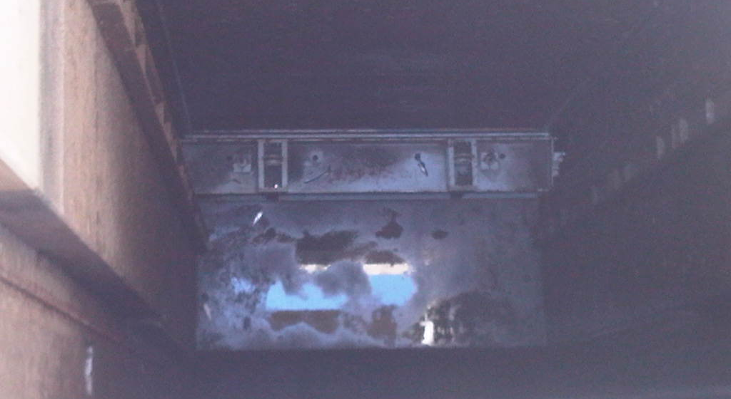
Bob Cordie
Fisheries Biologist
The Dalles Lock and Dam

